Mini Stepper Home Cardio Exercise Fitness Machine | LCD Display Monitor, Anti-slip Foot Pedals, Compact Design, Sturdy and Easy To Use
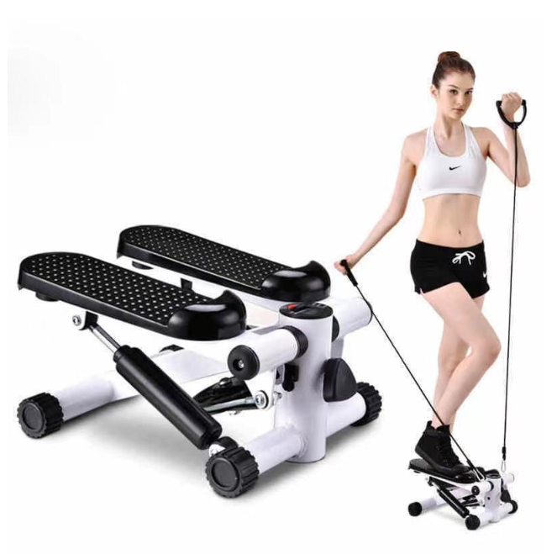

About this item
- LIGHTWEIGHT COMPACT DESIGN | Mini stepper, which is ideal for Cardio Fitness GYM training in the home, office or holiday. A must-have fitness tool to keep you health and hot at the same time
- PORTABLE MULTI USAGE PEDAL | The mini stepper will always be with you, you can use it in the office or at home, use the rest time to exercise. The stepper is really a perfect fitness equipment to shape your arms, hip, waist, legs and help build a perfect figure.
- DIGITAL LCD DISPLAY | The large screen LCD display monitors training time, distance, count, T-count, and calories burnt in a real time.
- ADJUSTABLE RESISTANCE | The effective training strength varies among different people. So, easly set your own with the intensity knob. Adjust the mini stepper to your resistance level, and start training right away.
- ANTI SLIP PEDALS & EASY TO USE | The base frame is high quality and durable, which endows the stepper with stability and long service life. Rubber protective casing can reduce the damage to floor, and prevent the stepper from slipping when using. Easy assembly, just several steps, you can finish complete assembly in a few minutes.

Technical Details
Style | ‎Mini Step
Material type | ‎Aluminum
Batteries included? | ‎No
Brand | ‎LMS Data
Manufacturer | ‎Dynamode
Package Dimensions | ‎34.8 x 23.4 x 22.4 cm; 5.54 Kilograms
ASIN | ‎B09DXPDNTN

